Monthly Report 3

- Date of Report:31/10/2025
- Student ID - Name: ISSAM AL AWAMLEH 21110241
- Major: CYBER SECRUITY
- Company: JODDB
- Department: cyber shield academy
- Industry Mentor: Ahmad ghneimat , Yoseef halaseh
- Apprenticeship Mentor: Shareef Shargawi
- Working days/hours:5 days (8AM-4PM)

Your report must cover these topics:
- Your role and responsibilities this month (+ evidence) :
My role was cyber security trainee I was helping the academy to prepare for C8 will be next month and a supporter for the instructor of the course I took. And here’s the board for this month:
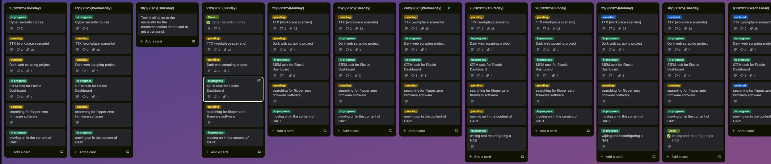
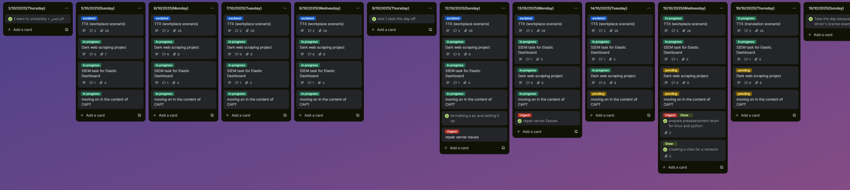

- Any problems / Challenges and how did you overcome them?
There was a problem of leaving time but it’s done by changing the mentor and become Youssef halasieh instead of Ahmad ghniemet.
There’s changing of the nature of the tasks but it’s normal because of ARMYTHON.

- Any training courses you attended during the apprenticeship, whether you opted for independently or through the employer.
  - Name of the course: CAPT certified associate penetration testing from Havkviser(individually)
  - Main Topics: Penetration testing
  - Copy of certification: done
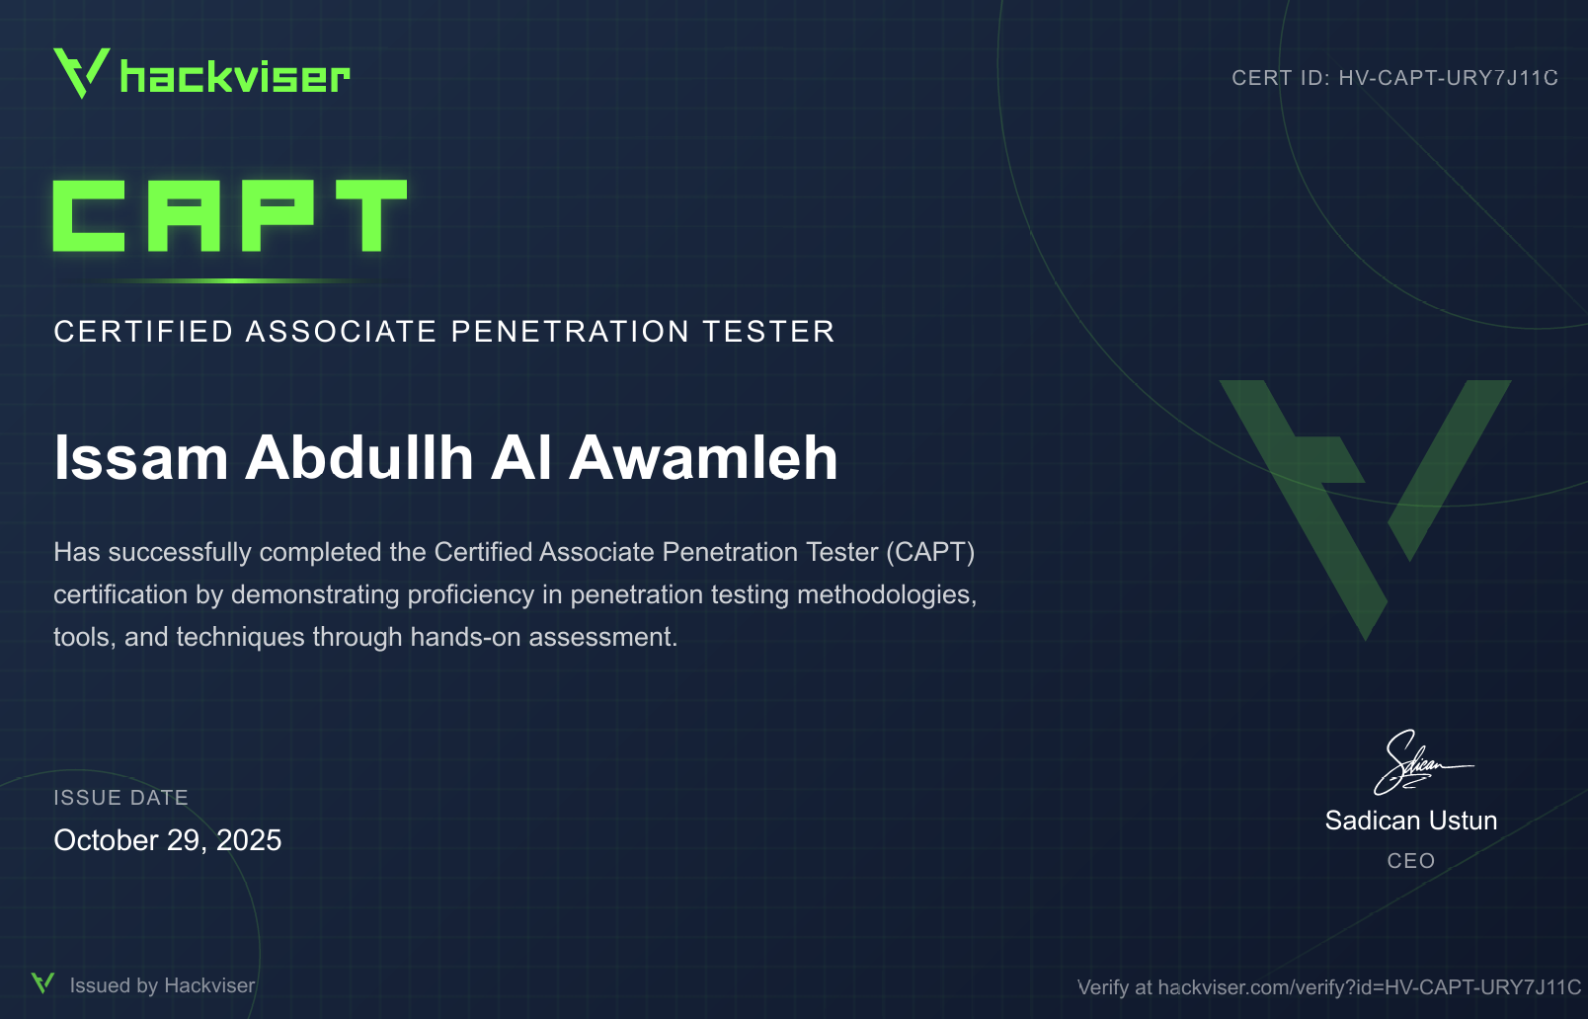
  - Name of the course: Red hat Linux administration
  - Main Topics: Linux
  - Copy of certification: done

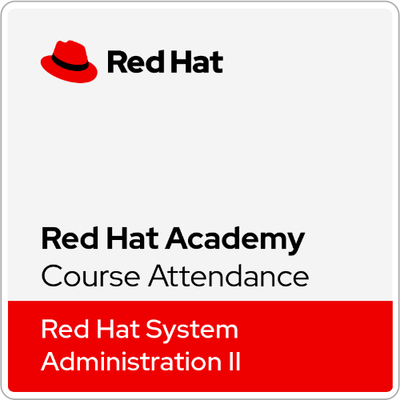

- What software /tools did you use?
Zeek, Logstash ,Kibana, elastic, Splunk, GitHub, fog project,ffuf, gobuster, feroxbuster, hackviser, cyberchief,Darkweb, Tor, BART -sentence(AI model), TI-IDF(AI model) , twinary, VMware, virtual box , ubuntu server, Hyper-V ,DC (domain controller), AD(Active Directory), Windows server 2019, Kerberos, kali OS, Scapy, Gitea, Moodle, Wazuh, OpenSSL, SSH service, Qnap, Qfinder, NAS storage, ,Microsoft Visio, Microsoft Word, Microsoft excel, python,VScode,katana, and suricata.

- Technical and non-technical skills
Teamwork, Patient ,research skill, Work under the pressure, analytic thinking, communication skills, multi-tasking, Time management, problem solving, negotiation and fast learning.

- Did you work on the National Occupational Standards (NOSs):
  - How many NOSs did you complete out of 5?0/5
  - List of NOSs (Number (URN) – Name of NOS)

- Events / Conferences you participated in
None this month

- Your Plan for Next Month.
- Working in ARMYTHON and prepare for it and do all the tasks asked for it.
- Get along with the new mentor.
- Keep going to complete CWSE(certified web security expert) from hackviser.
- Prepare for MCP exam cloud exam.
- Asking for technical tasks more.

